**Building a k-Nearest-Neighbors (k-NN) Model with Scikit-learn**

k-Nearest-Neighbors (k-NN) is a supervised machine learning model. Supervised learning is when a model learns from data that is already labeled. A supervised learning model takes in a set of input objects and output values. The model then trains on that data to learn how to map the inputs to the desired output so it can learn to make predictions on unseen data.

k-NN models work by taking a data point and looking at the ‘k’ closest labeled data points. The data point is then assigned the label of the majority of the ‘k’ closest points.

For example, if k = 5, and 3 of points are ‘green’ and 2 are ‘red’, then the data point in question would be labeled ‘green’, since ‘green’ is the majority (as shown in the above graph).

Scikit-learn is a machine learning library for Python. In this tutorial, we will build a k-NN model using Scikit-learn to predict whether or not a patient has diabetes.

**Reading in the training data**

For our k-NN model, the first step is to read in the data we will use as input. For this example, we are using the diabetes dataset. To start, we will use Pandas to read in the data. I will not go into detail on Pandas, but it is a library you should become familiar with if you’re looking to dive further into data science and machine learning.

import pandas as pd

#read in the data using pandas

df = pd.read_csv('/Users/user/Desktop/7BUIS008W/diabetes.csv')

#check data has been read in properly

df.head()

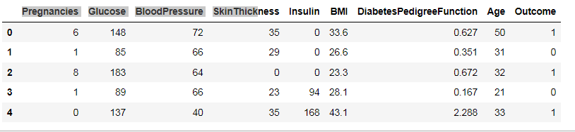

Figure : Diabetes Data Set

Next, let’s see how much data we have. We will call the ‘shape’ function on our dataframe to see how many rows and columns there are in our data. The rows indicate the number of patients and the columns indicate the number of features (age, weight, etc.) in the dataset for each patient.

#check number of rows and columns in dataset  
df.shape

We can see that we have 768 rows of data (potential diabetes patients) and 9 columns (8 input features and 1 target output).

**Split up the dataset into inputs and targets**

Now let’s split up our dataset into inputs (X) and our target (y). Our input will be every column except ‘diabetes’ because ‘diabetes’ is what we will be attempting to predict. Therefore, ‘diabetes’ will be our target.

We will use pandas ‘drop’ function to drop the column ‘diabetes’ from our dataframe and store it in the variable ‘X’. This will be our input.

*#create a dataframe with all training data except the target column*  
X = df.drop(columns=['Outcome'])

*#check that the target variable has been removed*  
X.head()

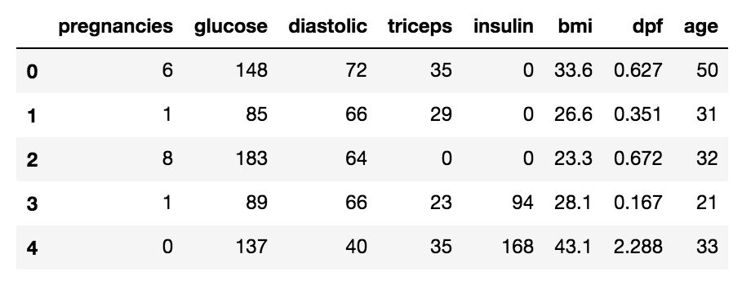

Figure Diabetes Training Set

We will insert the ‘diabetes’ column of our dataset into our target variable (y).

#separate target values  
y = df['Outcome'].values

#view target values  
y[0:5]

**Split the dataset into train and test data**

Now we will split the dataset into into training data and testing data. The training data is the data that the model will learn from. The testing data is the data we will use to see how well the model performs on unseen data.

Scikit-learn has a function we can use called ‘train_test_split’ that makes it easy for us to split our dataset into training and testing data.

from sklearn.model_selection import train_test_split

#split dataset into train and test data  
X_train, X_test, y_train, y_test = train_test_split(X, y, test_size=0.2, random_state=1, stratify=y)

‘train_test_split’ takes in 5 parameters. The first two parameters are the input and target data we split up earlier. Next, we will set ‘test_size’ to 0.2. This means that 20% of all the data will be used for testing, which leaves 80% of the data as training data for the model to learn from. Setting ‘random_state’ to 1 ensures that we get the same split each time so we can reproduce our results.

Setting ‘stratify’ to y makes our training split represent the proportion of each value in the y variable. For example, in our dataset, if 25% of patients have diabetes and 75% don’t have diabetes, setting ‘stratify’ to y will ensure that the random split has 25% of patients with diabetes and 75% of patients without diabetes.

**Building and training the model**

Next, we have to build the model. Here is the code:

from sklearn.neighbors import KNeighborsClassifier

# Create KNN classifier  
knn = KNeighborsClassifier(n_neighbors = 3)

# Fit the classifier to the data  
knn.fit(X_train,y_train)

First, we will create a new k-NN classifier and set ‘n_neighbors’ to 3. To recap, this means that if at least 2 out of the 3 nearest points to an new data point are patients without diabetes, then the new data point will be labeled as ‘no diabetes’, and vice versa. In other words, a new data point is labeled with by majority from the 3 nearest points.

We have set ‘n_neighbors’ to 3 as a starting point. We will go into more detail below on how to better select a value for ‘n_neighbors’ so that the model can improve its performance.

Next, we need to train the model. In order to train our new model, we will use the ‘fit’ function and pass in our training data as parameters to fit our model to the training data.

**Testing the model**

Once the model is trained, we can use the ‘predict’ function on our model to make predictions on our test data. As seen when inspecting ‘y’ earlier, 0 indicates that the patient does not have diabetes and 1 indicates that the patient does have diabetes. To save space, we will only show print the first 5 predictions of our test set.

#show first 5 model predictions on the test data  
knn.predict(X_test)[0:5]

We can see that the model predicted ‘no diabetes’ for the first 4 patients in the test set and ‘has diabetes’ for the 5th patient.

Now let’s see how our accurate our model is on the full test set. To do this, we will use the ‘score’ function and pass in our test input and target data to see how well our model predictions match up to the actual results.

#check accuracy of our model on the test data  
knn.score(X_test, y_test)

# accuracy of 0.7272

Our model has an accuracy of approximately 73%. It’s a good start, but we will see how we can increase model performance below.

**Comparing Error Rate with the K Value**

In the training and prediction section we said that there is no way to know beforehand which value of K that yields the best results in the first go. We randomly chose 5 as the K value and it just happen to result in 100% accuracy.

One way to help you find the best value of K is to plot the graph of K value and the corresponding error rate for the dataset.

In this section, we will plot the mean error for the predicted values of test set for all the K values between 1 and 40.

To do so, let's first calculate the mean of error for all the predicted values where K ranges from 1 and 40. Execute the following script:

error = []

*# Calculating error for K values between 1 and 40*

error = []

import numpy as np

import matplotlib.pyplot as plt

# Calculating error for K values between 1 and 40

for i in range(1, 40):

knn = KNeighborsClassifier(n_neighbors=i)

knn.fit(X_train, y_train)

pred_i = knn.predict(X_test)

error.append(np.mean(pred_i != y_test))

plt.figure(figsize=(12, 6))

plt.plot(range(1, 40), error, color='red', linestyle='dashed', marker='o',

markerfacecolor='blue', markersize=10)

plt.title('Error Rate K Value')

plt.xlabel('K Value')

plt.ylabel('Mean Error')

The output graph looks like this:

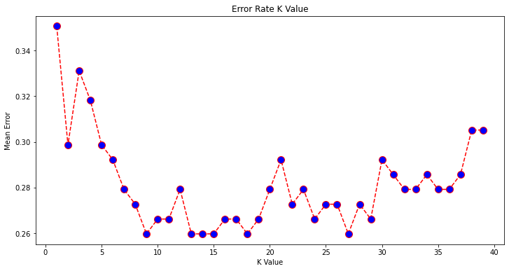

Figure : Error Rate K Value

**k-Fold Cross-Validation**

Cross-validation is when the dataset is randomly split up into ‘k’ groups. One of the groups is used as the test set and the rest are used as the training set. The model is trained on the training set and scored on the test set. Then the process is repeated until each unique group as been used as the test set.

For example, for 5-fold cross validation, the dataset would be split into 5 groups, and the model would be trained and tested 5 separate times so each group would get a chance to be the test set. This can be seen in the graph below.

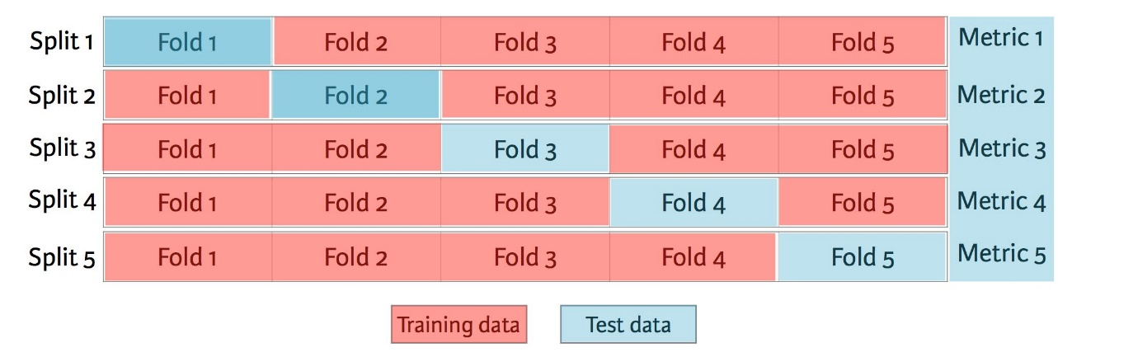

Figure : 5-fold cross validation

The train-test-split method we used in earlier is called ‘holdout’. Cross-validation is better than using the holdout method because the holdout method score is dependent on how the data is split into train and test sets. Cross-validation gives the model an opportunity to test on multiple splits so we can get a better idea on how the model will perform on unseen data.

In order to train and test our model using cross-validation, we will use the ‘cross_val_score’ function with a cross-validation value of 5. ‘cross_val_score’ takes in our k-NN model and our data as parameters. Then it splits our data into 5 groups and fits and scores our data 5 seperate times, recording the accuracy score in an array each time. We will save the accuracy scores in the ‘cv_scores’ variable.

To find the average of the 5 scores, we will use numpy’s mean function, passing in ‘cv_score’. Numpy is a useful math library in Python.

from sklearn.model_selection import cross_val_score  
import numpy as np

#create a new KNN model  
knn_cv = KNeighborsClassifier(n_neighbors=2)

#train model with cv of 5   
cv_scores = cross_val_score(knn_cv, X, y, cv=5)

#print each cv score (accuracy) and average them  
print(cv_scores)  
print(‘cv_scores mean:{}’.format(np.mean(cv_scores)))

Using cross-validation, our mean score is about 75%. This is a more accurate representation of how our model will perform on unseen data than our earlier testing using the holdout method.

**Hypertuning model parameters using GridSearchCV**

When built our initial k-NN model, we set the parameter ‘n_neighbors’ to 3 as a starting point with no real logic behind that choice.

Hypertuning parameters is when you go through a process to find the optimal parameters for your model to improve accuracy. In our case, we will use GridSearchCV to find the optimal value for ‘n_neighbors’.

GridSearchCV works by training our model multiple times on a range of parameters that we specify. That way, we can test our model with each parameter and figure out the optimal values to get the best accuracy results.

For our model, we will specify a range of values for ‘n_neighbors’ in order to see which value works best for our model. To do this, we will create a dictionary, setting ‘n_neighbors’ as the key and using numpy to create an array of values from 1 to 24.

Our new model using grid search will take in a new k-NN classifier, our param_grid and a cross-validation value of 5 in order to find the optimal value for ‘n_neighbors’.

from sklearn.model_selection import GridSearchCV

#create new a knn model  
knn2 = KNeighborsClassifier()

#create a dictionary of all values we want to test for n_neighbors  
param_grid = {‘n_neighbors’: np.arange(1, 25)}

#use gridsearch to test all values for n_neighbors  
knn_gscv = GridSearchCV(knn2, param_grid, cv=5)

#fit model to data  
knn_gscv.fit(X, y)

After training, we can check which of our values for ‘n_neighbors’ that we tested performed the best. To do this, we will call ‘best_params_’ on our model.

#check top performing n_neighbors value  
knn_gscv.best_params_

We can see that 14 is the optimal value for ‘n_neighbors’. We can use the ‘best_score_’ function to check the accuracy of our model when ‘n_neighbors’ is 14. ‘best_score_’ outputs the mean accuracy of the scores obtained through cross-validation.

#check mean score for the top performing value of n_neighbors  
knn_gscv.best_score_

By using grid search to find the optimal parameter for our model, we have improved our model accuracy to 76%!

## ****Gaussian Naive Bayes Classifier Example in Python Sklearn****

**Types of Naive Bayes Classifiers**

There are 3 types of Naive Bayes Classifiers –

1. Gaussian Naive Bayes. This classifier is used when the values of predictors are continuous in nature and it is assumed that they follow Gaussian distribution.
2. Bernoulli Naive Bayes. This classifier is used when the predictors are boolean in nature and it is assumed they follow Bernoulli distribution.
3. Multinomial Naive Bayes. This classifier uses multinomial distribution and is mostly used for document or text classification problems

In this section, we will take you through an end-to-end example of the Gaussian Naive Bayes classifier in Python Sklearn using a cancer dataset. We will be using the Gaussian Naive Bayes function of SKlearn i.e. GaussianNB() for our example.

### **Loading Initial Libraries**

We will start by loading some initial libraries to load and visualize the dataset.

import numpy as np

import pandas as pd

import matplotlib.pyplot as plt

### **Importing Dataset**

Now we will upload the cancer detection dataset that we have obtained from Kaggle for performing our Naive Bayes classification.

dataset = pd.read_csv('/Users/user/Desktop/7BUIS008W/data.csv')

### **Exploring Dataset**

Let us take an initial look into the dataset with the help of **head()** function.

dataset.head()

5 rows × 33 columns

Next, we will explore the columns present in the dataset through **info()** function.

dataset.info()

From the above information, we can see that **id** and **unnamed:32** columns are not useful, so we can remove them.

dataset = dataset.drop(["id"], axis = 1)

dataset = dataset.drop(["Unnamed: 32"], axis = 1)

### **Visualizing Dataset**

To visualize the dataset, we will first split the dataframe into two parts. The first part

 contains information about patients who have a malignant (dangerous) tumor and the other half data for benign (safe) tumor.

**Malignant Tumor Dataframe**

M = dataset[dataset.diagnosis == "M"]

**Benign Tumor Dataframe**

B = dataset[dataset.diagnosis == "B"]

We will now visualize the malignant and benign tumors by looking at the mean radius and mean texture of these tumours.

In [12]:

plt.title("Malignant vs Benign Tumor")

plt.xlabel("Radius Mean")

plt.ylabel("Texture Mean")

plt.scatter(M.radius_mean, M.texture_mean, color = "red", label = "Malignant", alpha = 0.3)

plt.scatter(B.radius_mean, B.texture_mean, color = "lime", label = "Benign", alpha = 0.3)

plt.legend()

plt.show()

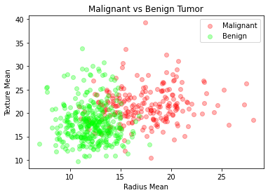

Figure : Malignant vs Benign Tumour

### **Pre-processing**

Now we will be assigning a value of ‘1’ to malignant tumors and ‘0’ to benign tumors.

dataset.diagnosis = [1 if i == "M" else 0 for i in dataset.diagnosis]

We now break our dataframe into x and y. The x contains all the independent predictor variables and y contains the prediction of diagnosis.

x = dataset.drop(["diagnosis"], axis = 1)

y = dataset.diagnosis.values

### **Data Normalization**

To improve the efficiency of the model it is always good to normalize data to bring them into a common scale.

# Normalization:

x = (x - np.min(x)) / (np.max(x) - np.min(x))

### **Test Train Split**

Now with the help of sklearn library train_test_split module, we will split the dataset into training and testing parts.

from sklearn.model_selection import train_test_split

x_train, x_test, y_train, y_test = train_test_split(x, y, test_size = 0.3, random_state = 42)

### **Sklearn Gaussian Naive Bayes Model**

Now we will import the Gaussian Naive Bayes module of SKlearn GaussianNB and create an instance of it. We can pass x_train and y_train to fit the model.

from sklearn.naive_bayes import GaussianNB

nb = GaussianNB()

nb.fit(x_train, y_train)

Output:

GaussianNB()

1. **Accuracy**

The following accuracy score on the test data shows how well our model Sklearn Gaussian Naive Bayes model has performed for predicting cancer.

print("Naive Bayes score: ",nb.score(x_test, y_test))

Output:

Naive Bayes score: 0.935672514619883

### **Sklearn Multinomial Naïve Bayes Model**

from sklearn.naive_bayes import MultinomialNB

from sklearn.metrics import accuracy_score

mnb = MultinomialNB()

mnb.fit(x_train, y_train)

y_pred = mnb.predict(x_test)

print('Accuracy: {:.2f}'.format(accuracy_score(y_test, y_pred)))

# Accuracy: 0.83